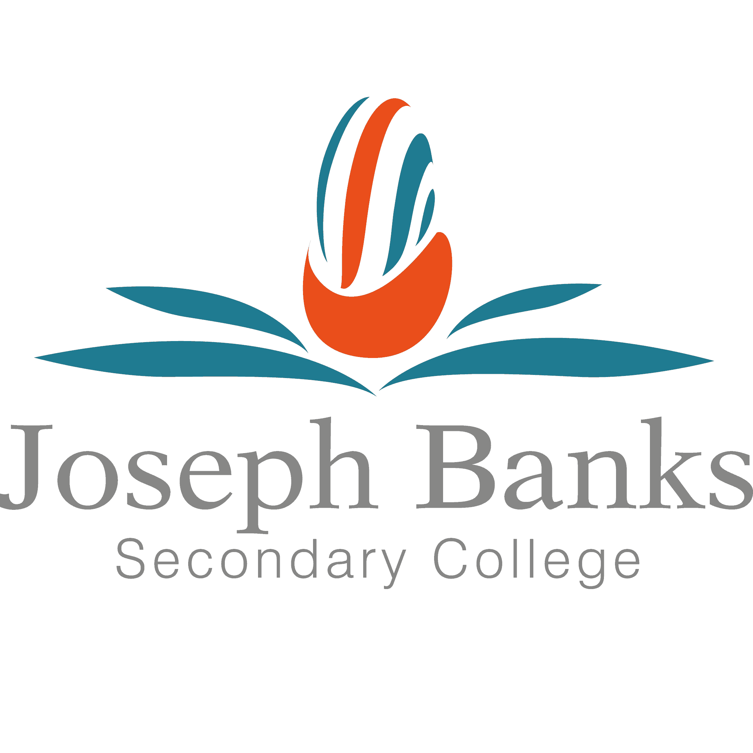
Joseph Banks Secondary College
OLNA Timetable – Round 1, June 2024
YEAR 11 ONLY

Overview
All students are required to pass all three components of the Online Literacy and Numeracy Assessment by the end of Year 12 to meet the requirements for WACE (Western Australian Certificate of Education). Students are provided with two attempts each year. The College has set a target that every student will meet the requirements for OLNA by the end of Year 12.

Timetable
Year 11  Writing Assessment - Week 9 |  |  |  |  | Year 11  Reading Assessment – Week 9 |  |  |  |  | Year 11  Numeracy Assessment – Week 9
Monday 10th June | Time | Location | Supervising Teacher |  | Wednesday 12th June | Time | Location | Supervising Teacher |  | Thursday 13th June | Time | Location | Supervising Teacher
Year 11 Students | Period 3 | Solander 5/6 | Milton  Remi |  | Year 11 Students | Period 2 | Discovery Centre | Muir  Williamson |  | Year 11 Students | Period 2 | Discovery  Centre | Milton  Ford
Students who have not yet met the standard for each assessment (Writing, Numeracy and Reading) are required to sit each specific assessment at the date, time and classroom listed below.

Students have been provided with an overview of which tests they are required to sit.

Students are required to go directly to their specific test at the date, time and location specified, rather than going to their timetabled class.

